***Railway Management System***

## Term Project on Object Oriented Programming

|  |  |
| --- | --- |
| **Group Members Group 2A - E** | |
| 180041208 | Fida Kamal |
| 180041223 | Shah Jawad Islam |
| 180041229 | Alvi Aveen Khan |

**Date of Submission: 16th September, 2020**

**Course Teacher Name:** Faisal Hussain

# Introduction

This project attempts to create a database management system to supervise, control and use the various parts of the national railway system.

# Proposal

The project will allow a user to use the system in both administrative and non-administrative roles. As an administrator, the user will be able to take control of the management of stations and trains. As a customer, the system will provide an interface to manage seat bookings.

# Description

The system is organized as follows. Users in the administrative role are able to add stations and trains that exist in the real world into the database. Trains keep track of their own schedules, including information about which stations they pass through at what times, and which seats are occupied at different stations. Stations keep track of the trains that pass through them throughout the day. Users in non-administrative roles are able to make bookings based on their points of departure and arrival. They are shown different options, given that there are multiple valid trains that fulfill their requirements. The user can choose to make a booking, at which point their personal information is added to a ticket and stored on an external file. All of this information is kept track of and is visible to any administrators.

# Features

**Administrative Features**:

* Add stations and trains into the database
* View information about purchased tickets

**Non-Administrative Features**:

* Book tickets
* View information about purchased tickets

**Common Features**:

* View schedules for different stations

# UML Diagram

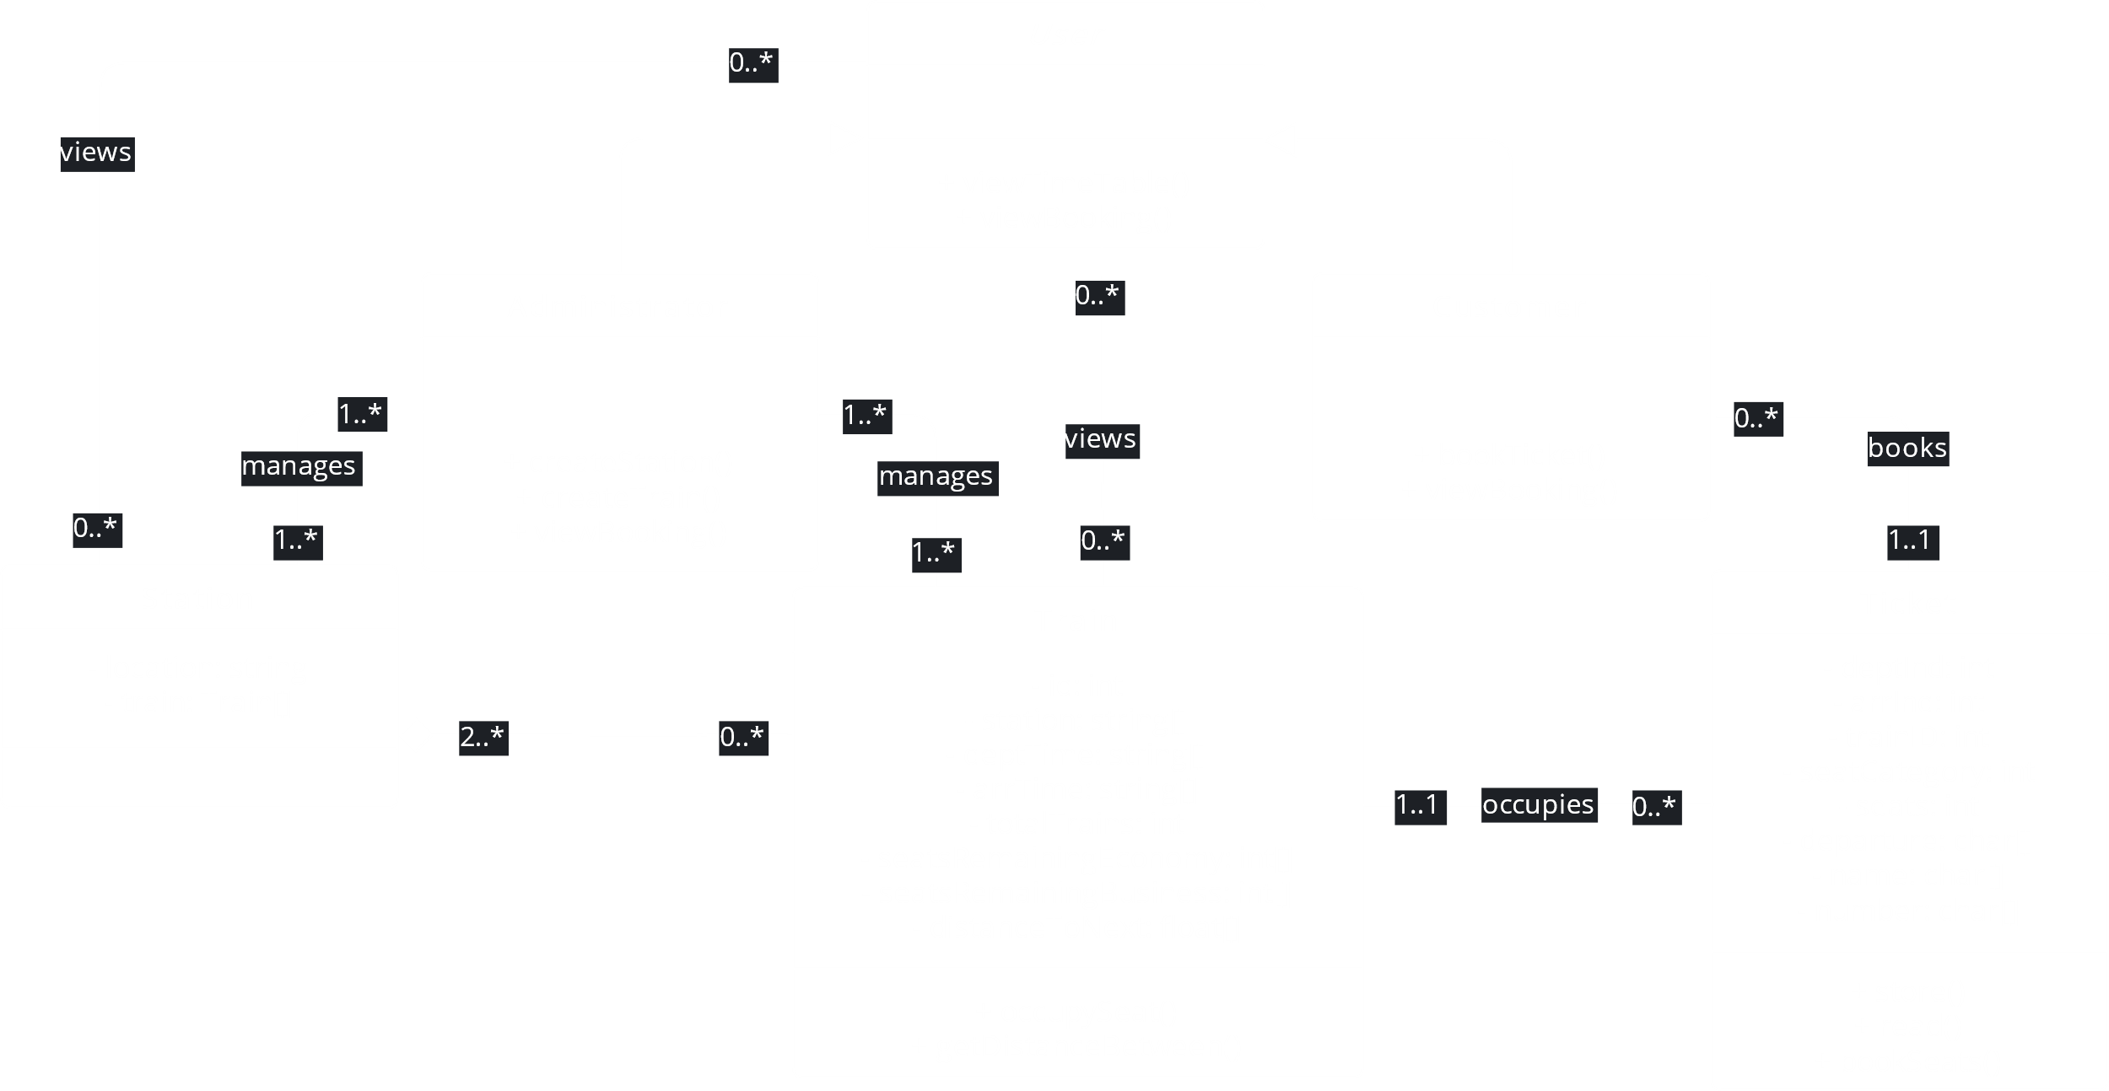

# Conclusion

This project attempts to provide an organized, systematic and user-friendly way for both administrators and non-administrators to manage all activities related to the national railway system. The team behind this project hopes that their work can provide a basis for a more feature-filled and visually pleasing platform that can be used in real life.